**Project Design Phase-II**

**Data Flow Diagram & User Stories**

|  |  |
| --- | --- |
| Date | 06 Jun 2025 |
| Team ID | LTVIP2025TMID59708 |
| Project Name | Citizen AI – Intelligent Citizen Engagement Platform |
| Maximum Marks | 4 Marks |

**Data Flow Diagrams:**

A Data Flow Diagram (DFD) is a traditional visual representation of the information flows within a system. A neat and clear DFD can depict the right amount of the system requirement graphically. It shows how data enters and leaves the system, what changes the information, and where data is stored.

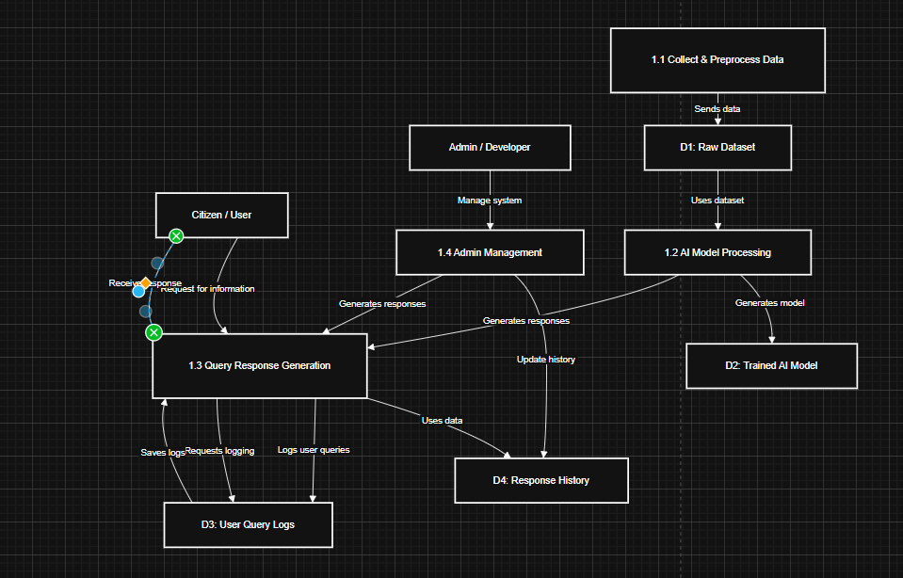**Example:** [**(Simplified)**](https://developer.ibm.com/patterns/visualize-unstructured-text/)

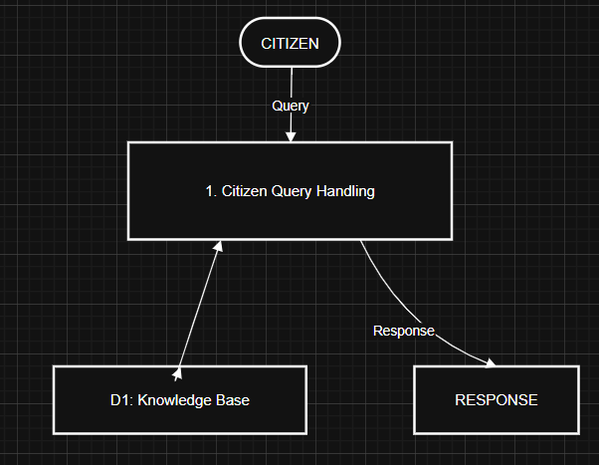

**User Stories**

Use the below template to list all the user stories for the product.

|  |  |  |  |
| --- | --- | --- | --- |
| **Previous Task (USN)** | **Description from Earlier Planning** | **Matches With New User Story** | **Sprint** |
| USN-5 | Frontend UI with HTML/CSS (includes registration/login) | USN-1, USN-2, USN-4, USN-5 | Sprint-1 |
| USN-6 | Flask-based backend deployment | Supports email/Gmail login | Sprint-1 |
| USN-7 | API Integration for frontend-backend | Supports login/registration | Sprint-1 |
| USN-8 | Input Validation | Validates form input fields | Sprint-1 |